**Extended Response Reaction Rates**

**Name:_________________**

Circle the letter that corresponds to the correct answer: (1 mark each)

1. Which answer is NOT correct? In terms of collision theory, a chemical reaction occurs only when

a) two reactant molecules collide with each other

b) reactants collide with sufficient energy to form new bonds

c) chemical bonds are broken by a catalyst

d) reactants collide with sufficient energy to break bonds in the reactants

**2.** Aspirin can be taken by drinking a cup of water in which an aspiring table has been dissolved. It can take several minutes for an aspirin tablet to dissolve. Several variables can be tested to see whether they influence the rate of this process:

I: temperature

II: surface area

III: pressure

IV: concentration

For the dissolving process, the most significant variables affecting rate would be

a) II and III only

b) I, II and IV only

c) I and II only

d) all of the variables

**3**. For the reaction shown in the equation below the fastest reaction will occur between

2HCl(aq) + CaCO3(s) 🡪 CaCl2(aq) + H2O(l) + CO2(g)

1. CaCO3 powder and 1.0M HCl
2. CaCO3 powder and 2.0M HCl
3. CaCO3 chipsand 2.0M HCl
4. CaCO3 chipsand 1.0M HCl

**4.** The rate of a chemical reaction will usually decrease as the reaction proceeds because

1. the catalyst becomes inactive
2. the concentration of reactants decreases
3. the temperature drops
4. the activation energy increases as the product concentrations increase

**5.** An increase in temperature increases a reaction rate

a) only because the particles collide with greater energy

b) because the particles collide with more frequency and greater energy

c) by providing an alternate pathway for the reaction to follow

d) only because there are more collisio

**6.** Consider the energy profile diagram below:

a) Does the diagram illustrate an exothermic or an endothermic reaction? State one reason, in terms of energy, to support your answer. (2 marks)

______________________________________________________

______________________________________________________

______________________________________________________

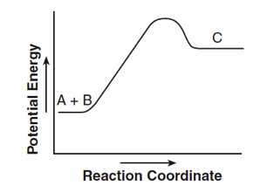

b) On the diagram provided*,* draw a dashed line to indicate a potential energy curve for the reaction if a catalyst is added. (1 mark)

**7.** The energy distribution diagram shows the distribution of kinetic energy for reacting particles at two different temperatures T1 and T2. Use this diagram to answer the following questions:

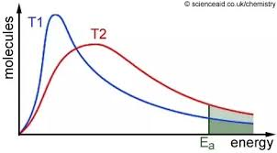

A

1. Explain what the line Ea represents: (2 marks)

_______________________________________________________________________________________

_______________________________________________________________________________________

b) What does the area labelled A represent? (1 mark)

_______________________________________________________________________________________

c) Add to the diagram to show what effect a catalyst would have. (1 mark)

**8.** The thermochemical equation for the combustion of natural gas is

CH4(g) + 2O2(g) 🡪 CO2(g) + 2H2O(g) ; ΔH = -803kJ

1. Sketch and label an energy profile diagram for this reaction: (2 marks)

b) How much energy is released during the complete combustion of 56.0g of methane? (2 marks)

c) What mass of oxygen would be taken from the atmosphere during the release of 2250kJ of energy? (2 marks)

**9.** Carbon Dioxide gas is generated as shown below by reacting marble chips (calcium carbonate) with 1.0 molL-1 hydrochloric acid. As the reaction proceeds the volume of CO2 gas produced was measured at regular intervals. The results are shown graphically below;

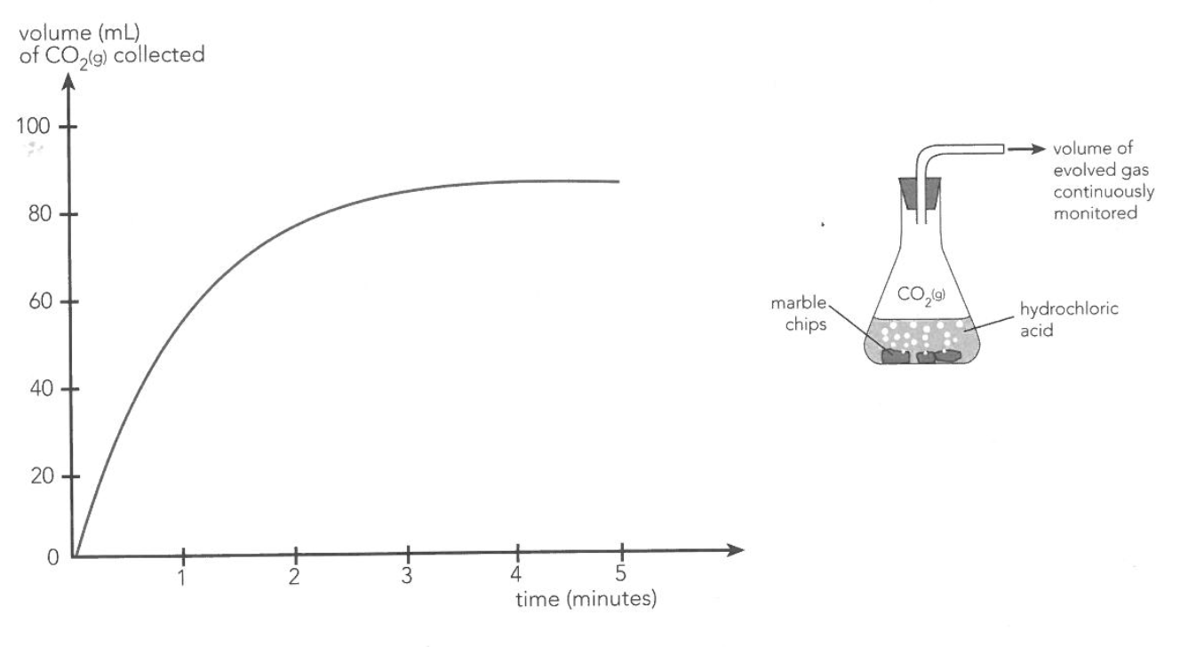

1. Write a balanced chemical Equation for the reaction

_______________________________________________________________________________________

1. Write a Net Ionic Equation for the reaction

_______________________________________________________________________________________

1. Use the graph to determine when the reaction rate is greatest

_______________________________________________________________________________________

_______________________________________________________________________________________

1. Explain why the rate of reaction changes as the reaction proceeds

_______________________________________________________________________________________

_______________________________________________________________________________________

_______________________________________________________________________________________

_______________________________________________________________________________________

1. Explain what happens in the reaction after the first 4 minutes

_______________________________________________________________________________________

_______________________________________________________________________________________

1. What other quantity could have been measured and graphed in order to monitor the rate of this reaction?

_______________________________________________________________________________________

1. This reaction was carried out using 1.0 mol L-1 HCL. If the experiment was repeated using 2.0 mol L-1 HCl acid;
2. How would the reaction be different?

____________________________________________________________________________________

1. Why?

____________________________________________________________________________________

1. Indicate on the Graph a likely result.

**End of Paper**